Alex Arnold
Professor Torres
3-20-25
IT 120-41198
Lab 8

Part A: NetlabLinks to an external site.
Log on to NetlabNDG Security+ v3, Lab 01, Investigating ARP Poisoning, Windows 2012R2, and adjust the security utilizing the Windows Benchmark settings below. Capture a screenshot of the results of each major command. If you cannot enforce any of the policies, state why. Utilizing Windows benchmark, adjust the security policy for the below utilizing CIS benchmarkLinks to an external site.:

1.1 Password Policy:
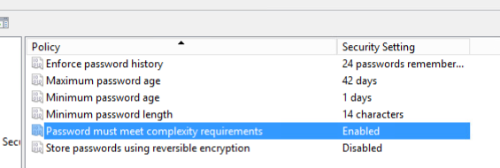
1.1.1 (L1) Ensure 'Enforce password history' is set to '24 or more password(s)'
1.1.2 (L1) Ensure 'Maximum password age is set to '60 or fewer days, but not 0'
1.1.3 (L1) Ensure 'Minimum password age is set to '1 or more day(s)'
1.1.4 (L1) Ensure 'Minimum password length is set to '14 or more character(s)'
1.1.5 (L1) Ensure 'Password must meet complexity requirements' is set to 'Enabled'

1.2 Account Lockout Policy
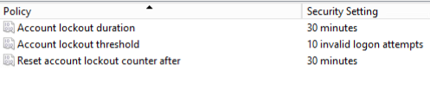
1.2.1 (L1) Ensure 'Account lockout duration' is set to '15 or more minute(s)'
1.2.2 (L1) Ensure 'Account lockout threshold is set to '10 or fewer invalid logon attempt(s), but not 0'
1.2.3 (L1) Ensure 'Reset account lockout counter after' is set to '15 or more minute(s)'

9.2 Private Profile
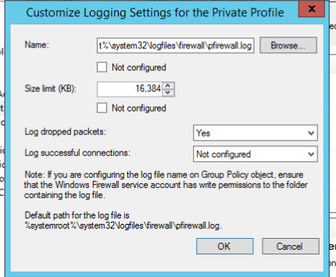
9.2.7 (L1) Ensure 'Windows Firewall: Private: Logging: Name' is set to '%SYSTEMROOT%\System32\logfiles\firewall\privatefw.log' (Scored)
9.2.8 (L1) Ensure 'Windows Firewall: Private: Logging: Size limit (KB)' is set to '16,384 KB or greater' (Scored)
9.2.9 (L1) Ensure 'Windows Firewall: Private: Logging: Log dropped packets' is set to 'Yes' (Scored)

17.2 Account Management (Tricky one, take your time, it is there. The path is different)
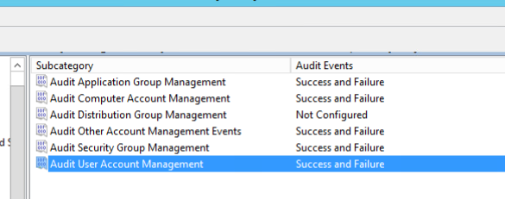
17.2.1 (L1) Ensure 'Audit Application Group Management' is set to 'Success and Failure'
17.2.2 (L1) Ensure 'Audit Computer Account Management' is set to 'Success and Failure'
17.2.3 (L1) Ensure 'Audit Other Account Management Events' is set to 'Success and Failure'
17.2.4 (L1) Ensure 'Audit Security Group Management' is set to 'Success and Failure'
17.2.5 (L1) Ensure 'Audit User Account Management' is set to 'Success and Failure'

18.9.26.1 Application
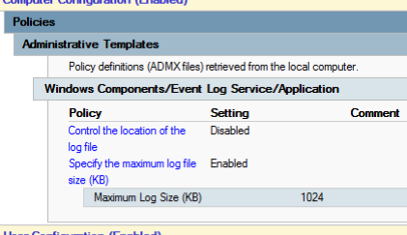
18.9.26.1.1 (L1) Ensure 'Application: Control Event Log behavior when the log file reaches its maximum size is set to 'Disabled' (Scored)
18.9.26.1.2 (L1) Ensure 'Application: Specify the maximum log file size (KB)' is set to 'Enabled: 32,768 or greater (Scored)

18.9.26.2 Security
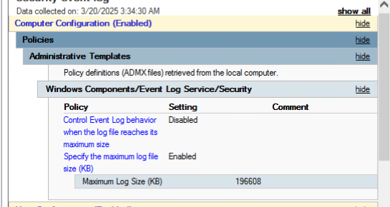
18.9.26.2.1 (L1) Ensure 'Security: Control Event Log behavior when the log file reaches its maximum size is set to 'Disabled' (Scored)
18.9.26.2.2 (L1) Ensure 'Security: Specify the maximum log file size (KB)' is set to 'Enabled: 196,608 or greater' (Scored)

18.9.26.4 System
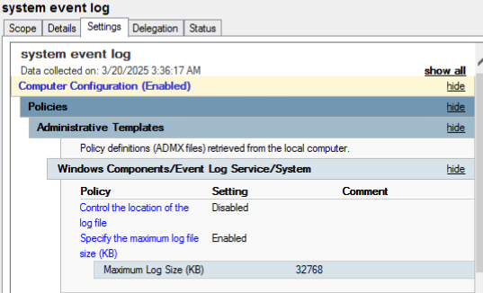
18.9.26.4.1 (L1) Ensure 'System: Control Event Log behavior when the log file reaches its maximum size is set to 'Disabled' (Scored)
18.9.26.4.2 (L1) Ensure 'System: Specify the maximum log file size (KB)' is set to 'Enabled: 32,768 or greater (Scored)

Part B:
For this part, review the videos below and give your opinion. For best results, try running all of the commands on your Linux system or in Netlab

Intro to LinuxLinks to an external site.
- PWD, LS, CD, CP (copy), RM, mkdir, rmdir,
- Interesting and useful commands but they are just the basics for moving and manipulating files / directories in the file system. I have been doing that for a while.
Linux DistributionsLinks to an external site.
- Ubuntu, Linux mint, Fedora, openSUSE, Arch
- Personally I prefer to use Ubuntu as a desktop operating system on a laptop. Mint is also nice to us. For openSUSE and ARCH I have never really personally used. I had heard that ARCH was a more technical and detailed OS to use.
Linux CommandsLinks to an external site.
- I really like the volume of content that is covered in this video and also the simplified explanations that are given. There are a good number of commands that are in this video that wont work in netlab due to the age of the os distributions.
Linux LogsLinks to an external site.
- By far the most useful one for me to review where the log files are and what some of the important log files are. I quite liked the video though the speaker is rather monatone. The use of special code such as last to view binary files is super important.
Linux NetworkingLinks to an external site.
- the audio in this video needs work. The commands seem to be simple for the most part and things we have already covered. Or people have used if they have used a linux system. Also half the video is ifconfig and ping.

Part C:
Search the internet for "Best Practices" on Linux systems:
List 10 best practices for Linux
https://www.cyberciti.biz/tips/linux-security.html
- Encrypt Data Communication For Linux Server
- Avoid Using FTP, Telnet, And Rlogin / Rsh Services on Linux
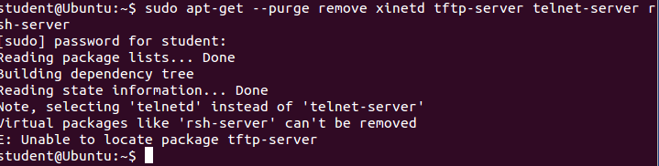
- Minimize Software to Minimize Vulnerability in Linux
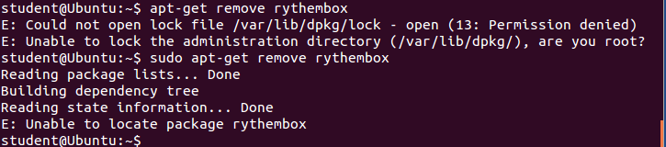
- One Network Service Per System or VM Instance
- Keep Linux Kernel and Software Up to Date
# apt-get update && apt-get upgrade (cant upgrade due to lack of internet but this is the command to do it)
- Linux User Accounts and Strong Password Policy
- Set Up Password Aging For Linux Users For Better Security
- Locking User Accounts After Login Failures
- Make Sure No Non-Root Accounts Have UID Set To 0
- Disable root Login
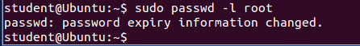
Root account locked
Perform 5 of the best practices on NetlabNDG Security+ v3, Lab 01 -The Ubuntu system

